B. 1. Function avg returns the average of three values, as given in this chapter. Which of the following statements, each making calls to function avg, are valid? (Assume that all variables are of numeric type.)

B, C, D, E.

3. Using functions avg and max, give an expression that computes the average as shown above.

result = avg (max1 + max2 + max3) / 3.0

5. For the following function definition and associated function calls,

a. List all the formal parameters.

n1 and n2

b. List all the actual parameters.

num1 and 15

C. P1.

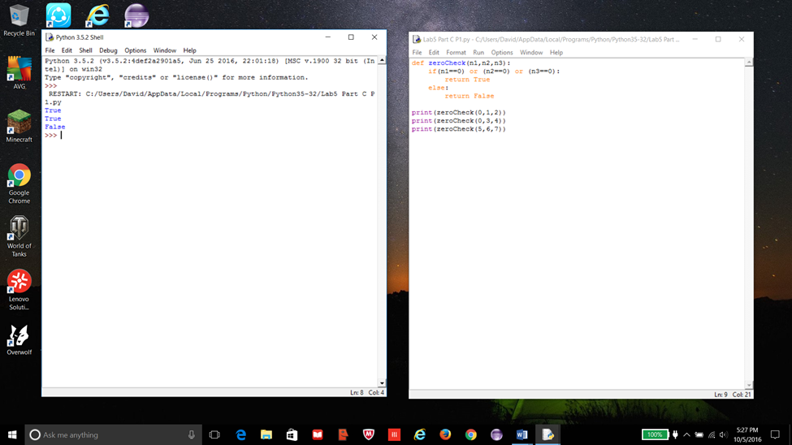P3.

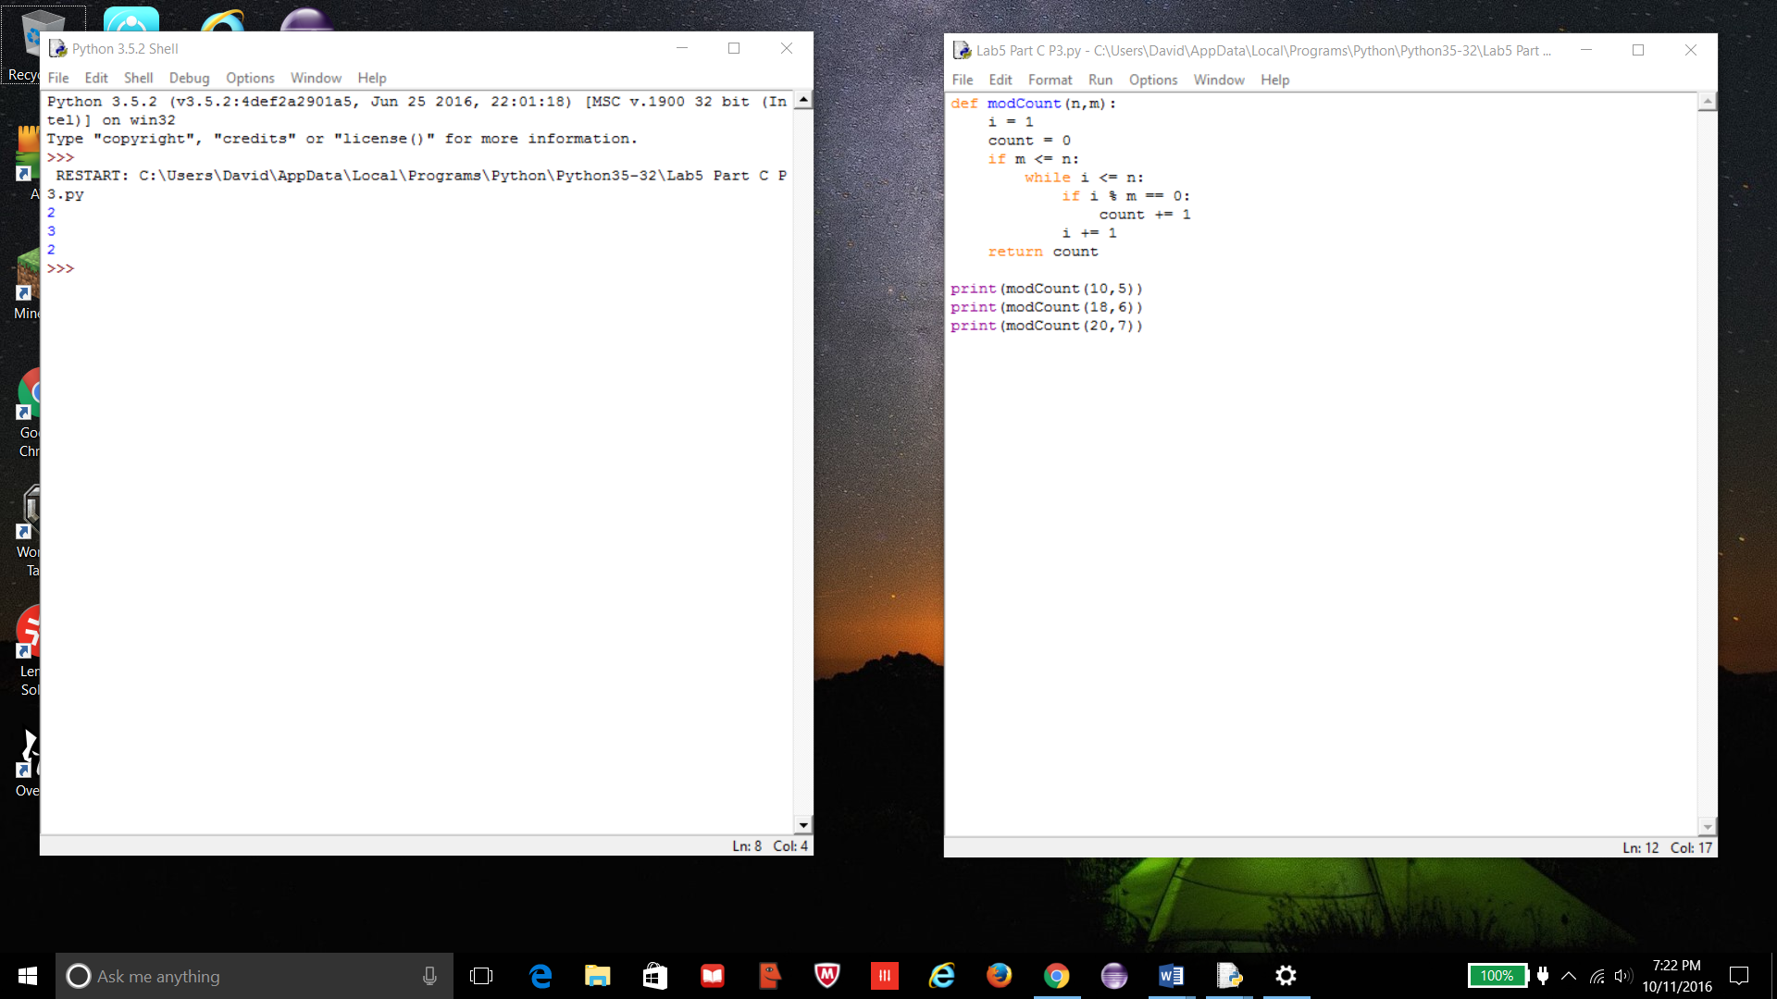P5.

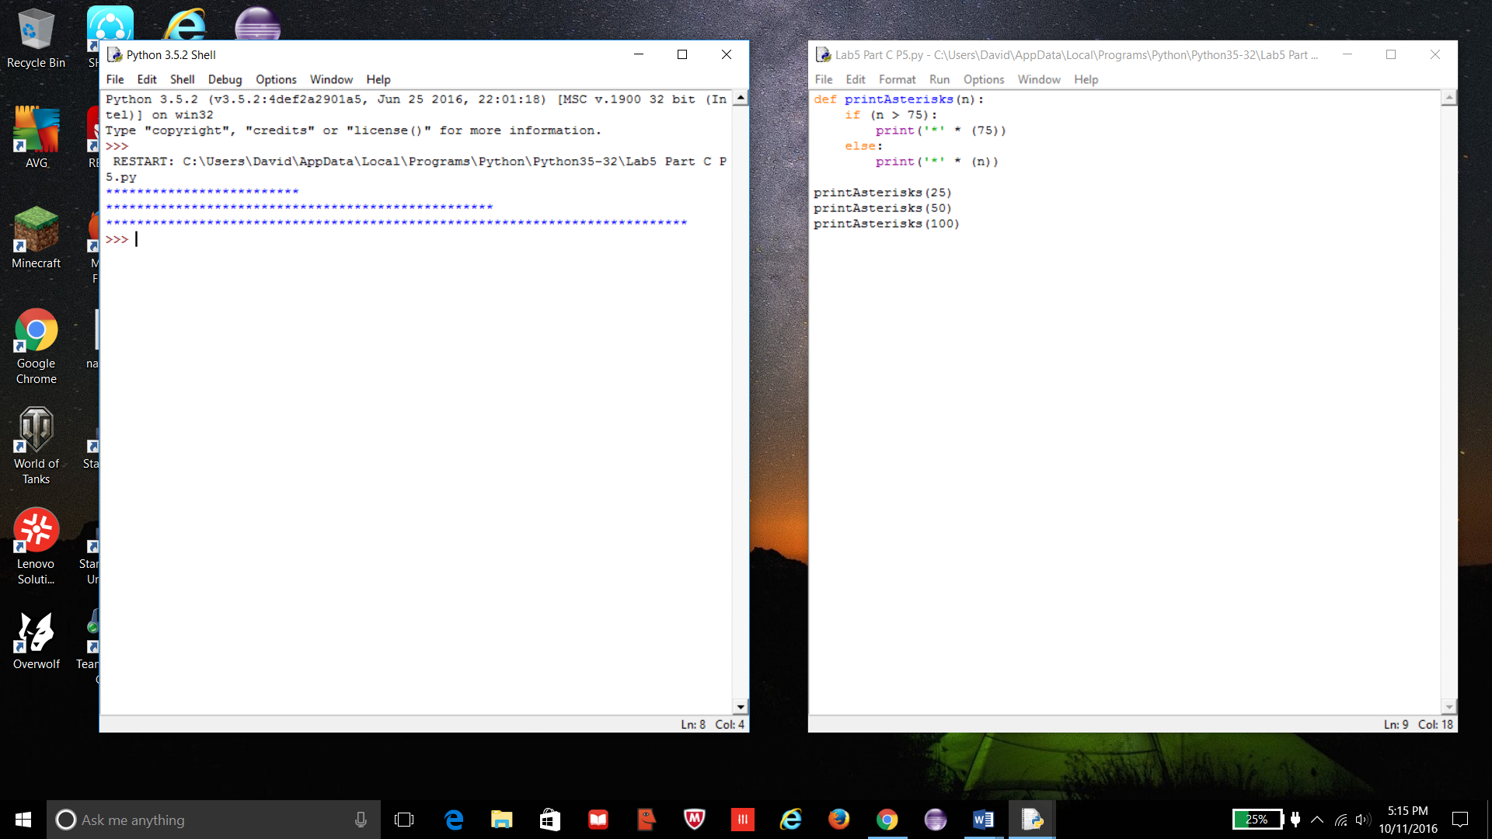

D. https://earsketch.gatech.edu/earsketch2/#?sharing=vevT9N3xRNCCuTj5zKxB3g